20IT4303: ADVANCED DATA STRUCTURES & ALGORITHMS
HOME ASSIGNMENT-4 QUESTIONS
A.Y:2021-22
S.NO | QUESTION | COURSE OUTCOME | BTL
1 | 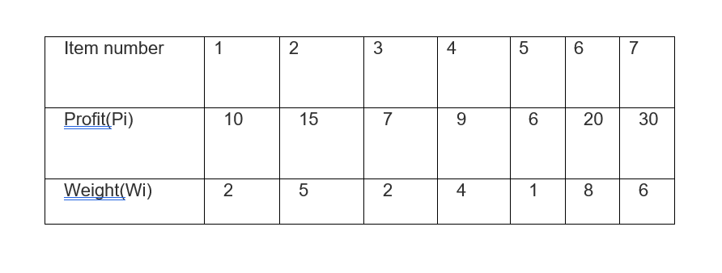  Solve the problem as 0/1 Knapsack problem to find the optimal solution using Branch-and-Bound technique | CO3 | Apply
6 | Solve the problem as Travelling Salesperson Problem to find the optimal route using Branch-and-Bound technique with ’A’ as the starting point.  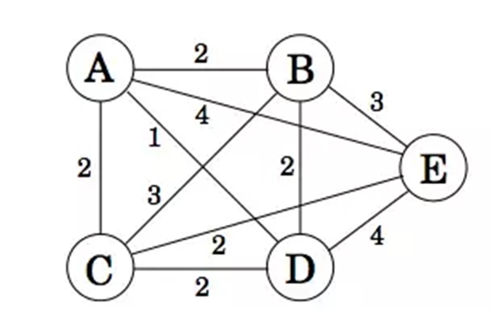 | CO3 | Apply
11 | Differentiate between Deterministic and non-deterministic algorithms with examples. | CO4 | Apply
12 | Differentiate P, NP, NP-hard and NP-Complete problems. | CO4 | Analyze

Regd.No | Question Number | Regd.No | Question Number | Regd.No | Question Number
208W1A1277 | 4,9,11,12 | 208W1A1299 | 1,6,11,12 | 208W1A12C3 | 3,8,11,12

